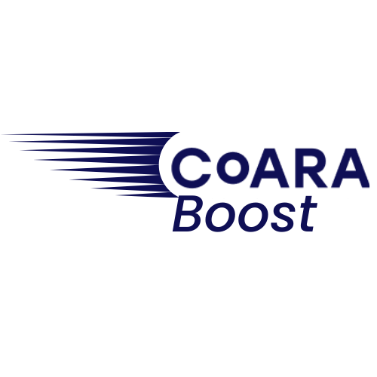


Coalition for Advancing Research Assessment

CoARA Boost Cascade
Funding Programme

Application Template – Second Round

Opening: 21 February 2025
Closing: 23rd April 2025 at 17:00 CEST
Funding Call information, documents and templates:
https://coara.eu/second-call-for-cascade-funding/ ‎
Funding Call Application Platform: https://esf.smartsimple.ie/s_signup.jsp?token=XVtQC1oGYV5ZSxtZXxJXR1JWYUl1H3Rt

CoARA Boost Cascade Funding Call 2
Proposal Application Form - Template
The use of the Application Form Template is mandatory – please refrain from deleting any sections and adhere to the specified page limit (please do not exceed 5 pages, all included, i.e., figures, tables, charts, etc.) – font-size Arial 11.
This template must be correctly filled in and uploaded on the SmartSimple submission platform. You must also upload the Excel table “Project Budget Template” according to your type of project:
- Annex 4 - for unique partner (i.e., Individual Pilot Change and Institutional Change Projects) OR
- Annex 5 - for partnering projects (i.e., Teaming Project)
Please note that both documents (Application form and Budget) are mandatory to apply to CoARA Cascade Funding.

Organisation
(Name – Town, Country)  (Description in 5 lines maximum) | Logo
Is your organisation currently a signatory of the Agreement or a full member of the Coalition for Advancing Research Assessment (CoARA)? | ☐Signatory  ☐Member  ☐None

Project title
(To be completed)

Project abstract (max. 200 words)
(To be completed)

PAGE COUNT STARTS HERE
Link to the Action Plan of the organisation(s), to implement commitments of the Agreement on Reforming Research Assessment (if available). If the organisation is not ARRA Signatory, please leave this section blank.
(To be completed)

For teaming calls: name and contact details of the partner organisation(s)
(To be completed)

Short description of the mission and objectives of the proposal, and how it fits with the overall vision of the Agreement on Reforming Research Assessment (publishable summary of the project).
Are the mission, impact, work plan and intended outputs of the project carefully and specifically aligned with CoARA’s vision as specified in the Agreement?
(To be completed, max. 200 words)

Agreement core commitment(s) (listed below 1.-4.) which is/are supported by the project
Please select one or more among the following:
- Recognise the diversity of contributions to, and careers in research according to the needs and the nature of the research | ☐
- Base research assessment primarily on qualitative evaluation for which peer-review is central, supported by responsible use of quantitative indicators | ☐
- Abandon inappropriate uses in research assessment of journal- and publication-based metrics, in particular inappropriate uses of journal impact factor (JIF) and h-index | ☐
- Avoid the use of rankings of research organisations in research assessment | ☐

Agreement supporting commitment(s) (listed below), the implementation of which is/are supported by the project (optional):
Please select one or more among the following
- Commit resources to reforming research assessment as is needed to achieve the organisational changes committed to | ☐
- Review and develop research assessment criteria, tools and processes:
- With the direct involvement of research organisations and researchers at all career stages, review and develop criteria for assessing research units and research performing organisations, while promoting interoperability | ☐
- With the direct involvement of researchers at all career stages, review and develop criteria, tools and processes for the assessment of research projects, research teams and researchers that are adapted to their context of application | ☐
- Raise awareness of research assessment reform and provide transparent communication, guidance, and training on assessment criteria and processes as well as their use | ☐
- Exchange practices and experiences to enable mutual learning within and beyond the Coalition | ☐
- Communicate progress made on adherence to the principles and implementation of the Commitments | ☐
- Evaluate practices, criteria and tools based on solid evidence and the state-of-the-art in research on research, and make data openly available for evidence gathering and research | ☐

Expected impact and sustainability of the reform process, how it leads to institutional change as well as the added value of the project over and beyond what is currently being done within the community*:
• For teaming projects: the rationale behind forming the team is well defined, clearly maps into the proposed impact, and is key to tangible institutional change. Knowledge transfer mechanisms and mutual benefits are guaranteed.
• For institutional change projects: the proposed work plan and outputs provide the means to accelerate tangible and sustainable change in an organisation’s procedures and processes.
• For pilot projects: the new assessment approaches are suitable, feasible and fit well into the organisation’s overall research assessment strategy.
(To be completed, max. 400 words)

Work plan, Resources, and outputs/deliverables
Does the proposal come with a clear and specific vision that, regardless of the granularity, scope, and type of the work, is very likely to provide a solid contribution to systemic change of research assessment within the institution? Are there safeguards in place for the implementation plan?
Is there a solid added value of the project over and beyond what is currently being done within the community, including CoARA Working Groups?
Does the mission and proposed impact of the project translate well into the work plan? Does the work plan seem to be feasible within the proposed time frame? Does the work plan come with clear and achievable milestones and deliverables?
Are there mechanisms in place to engage those who are affected by the envisaged reform process (e.g. researchers at all career stages)?
A clear outline of activities, tasks and milestones/KPIs should also be included here. These should be further elaborated in the ‘Financial use of resources’ Excel file attached to the application.
(To be completed, max. 600 words)

Mechanisms to engage those who are affected by the envisaged reform process (e.g. researchers at all career stages)
(To be completed, max. 600 words)

